**Solution Sheet**

1. Which model have you used for probability prediction? Explain your model.

* After preprocessing (Notebook: Covid-19 Data Preprocessing.ipynb) and filling missing variables with suitable information and selected 24 features.
* Used a Sequential Keras Model with the following parameters:

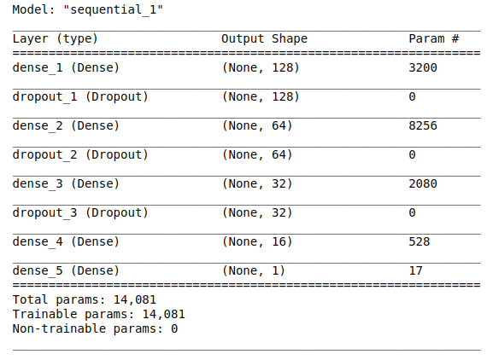

* Used “adam” optimizer as it is reliable in reaching a global minimum and used “mean squared error” loss function and ran for 50 epochs with a batch size of 32.
* Why this kind of model? As in the VGG paper, they have used activations in powers of 2. So, that’s the inspiration behind these numbers.
* Also, dropout is used with a 50% rate to prevent the model from relying heavily on any particular layer or hidden units.
* `ReLu` activation is used as it is the industry standard.
* Result: The model reported a loss: 0.009516 on the validation test set created separately to prevent bias creeping into the model.
* Data File: “Results/20March_Task-1_Results.csv”
* Notebook: Task-1.ipynb

1. Which model have you used for Diuresis Time series prediction? Explain your model.

* As we have 6 days of data. So, using consecutive pairs of days as input and output values, a new dataset was created.
* I used an LSTM Deep learning model using Keras Library with the following parameters:

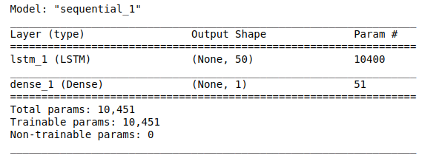

* Used “adam” optimizer as it is reliable in reaching a global minimum and used “mean squared error” loss function and ran for 10 epochs with a validation split of 0.2.
* After training, used the model and test dataset 20th March “Diuresis” data to predict 27th March “Diuresis” data using a 7-day for-loop.
* Then again run the model from Task-1 to get the “Infect_prob" for 27th March.
* Data File: “Results/27March_Task-2_Results_reg.csv”
* Notebook: Task-2.ipynb